**FE-582 Foundations of Financial Data Science, Spring 2021**

**Group 5: Daniel Bachalis, Gurjivan Kalkat, Naveen Nagarajan**

**Forecasting stock prices during pandemic**

**Introduction:**

The current pandemic has affected global markets and economies tremendously, especially in the United States. The research being performed will look at the performance and correlations across commodities, macroeconomic indicators, equity indices, COVID 19 data, and TSA data before and after the pandemic. Certain assets and commodities performed better post pandemic while others are still lagging in terms of returns. An initial model will be created starting from the beginning of 2019 to the start of the pandemic. The model will then be changed to account for the current environment. Based upon the analysis of this data, a determination will be made as to the best asset allocation for investors and what can be expected going forward.

**Research statement (questions):**

We will use data science techniques to do the following:

* Predict which business cycle we are currently in and how long it will last as it relates to the Covid-19 pandemic.
  + Develop Covid-19 prediction model to leverage for pandemic duration prediction.
  + Use the previous housing crisis recession as a reference.
    - We will look at overall trends from during the previous recession, see what applies to the current situation.
    - We will temper those details based on differences in the type of crisis we're facing and call out differences in assumptions.
* Make recommendations for portfolios and asset allocation in order to maximize returns and hedge against risk.

**Data:**

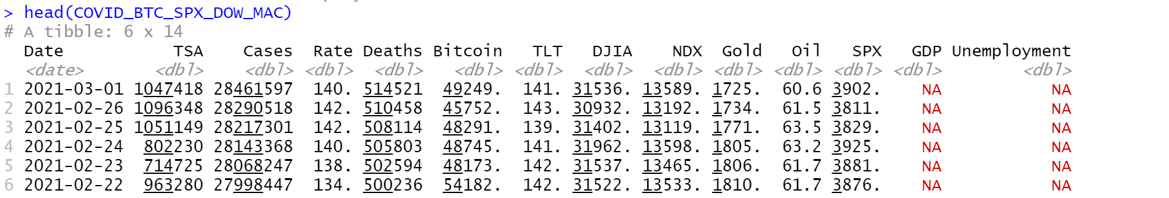

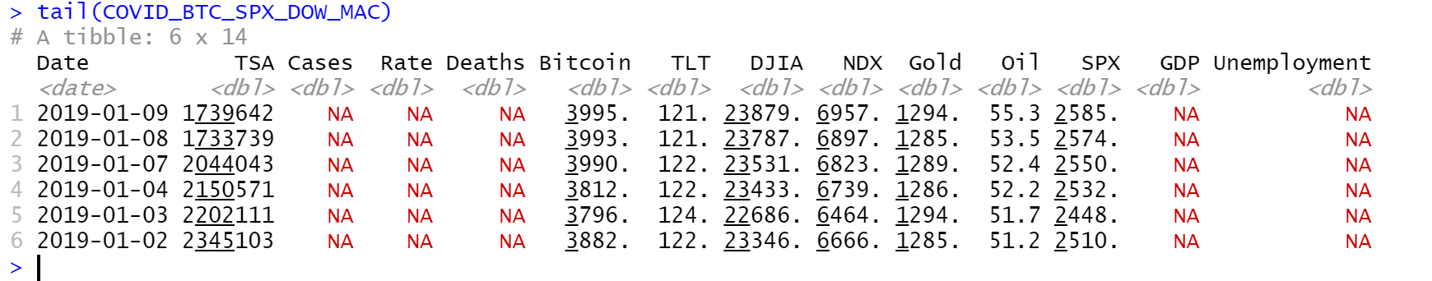

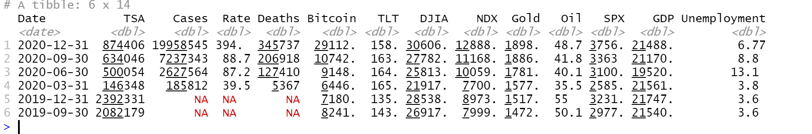

Datasets were retrieved from bloomberg [3]

**Exploratory Data Analysis (EDA):**

The following figures below display the initial summary statistics for all of the data:

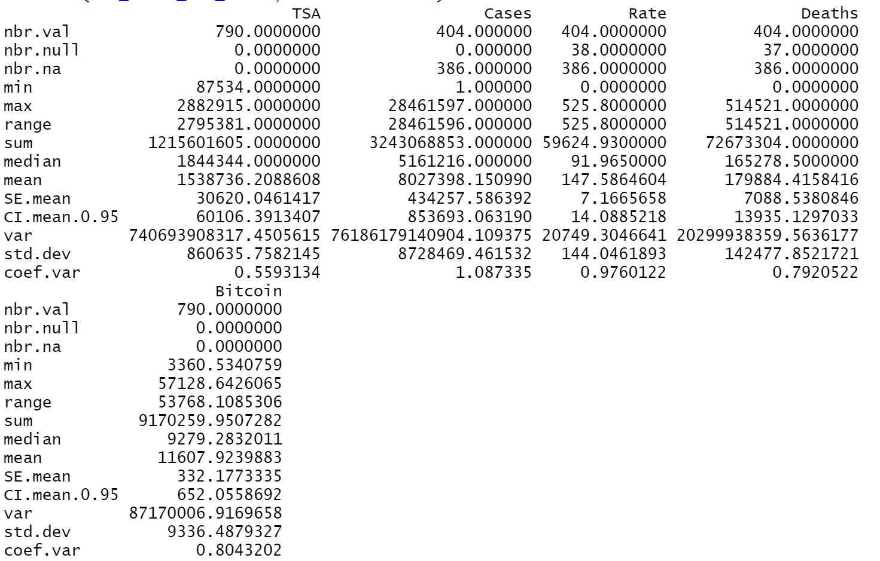

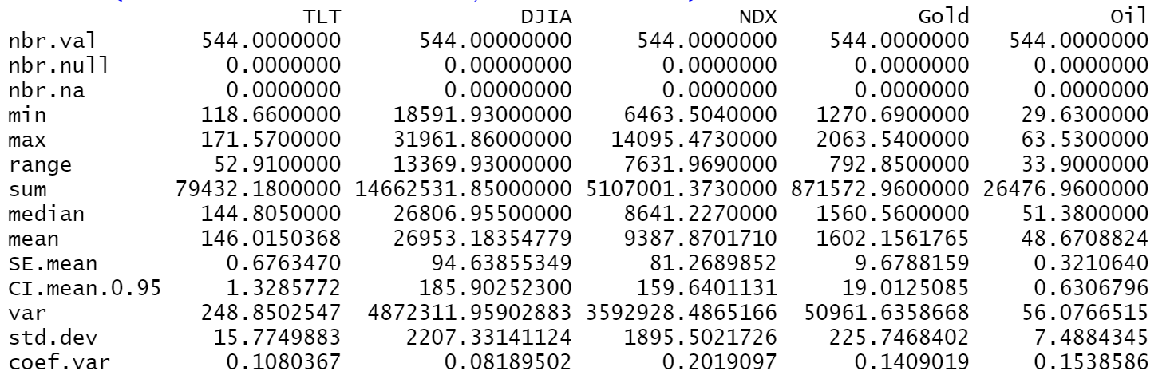

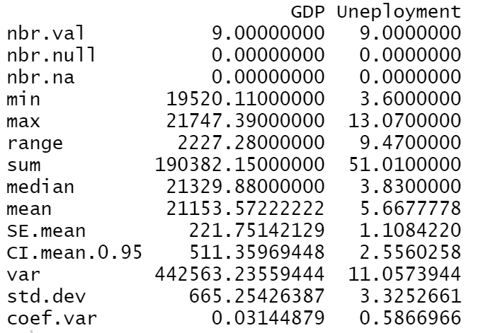

The following graphs and plots attempt to look at multiple data sets and make predictions about how the assets are correlated to each other and how COVID 19 changed these correlations:

**TSA and COVID 19 Comparison**

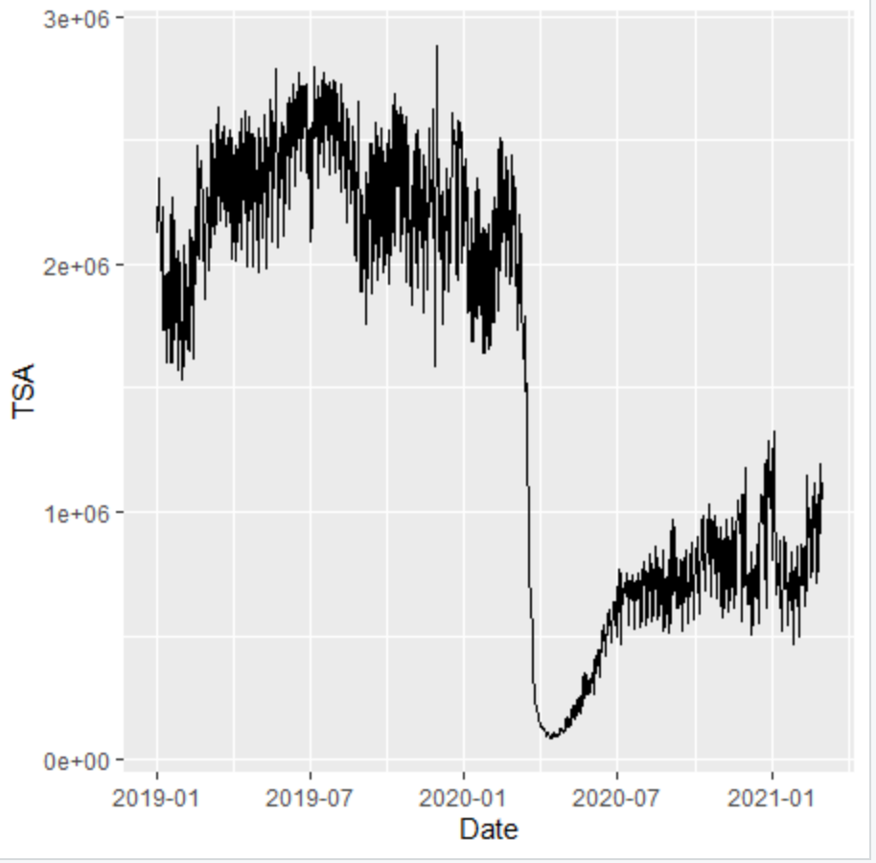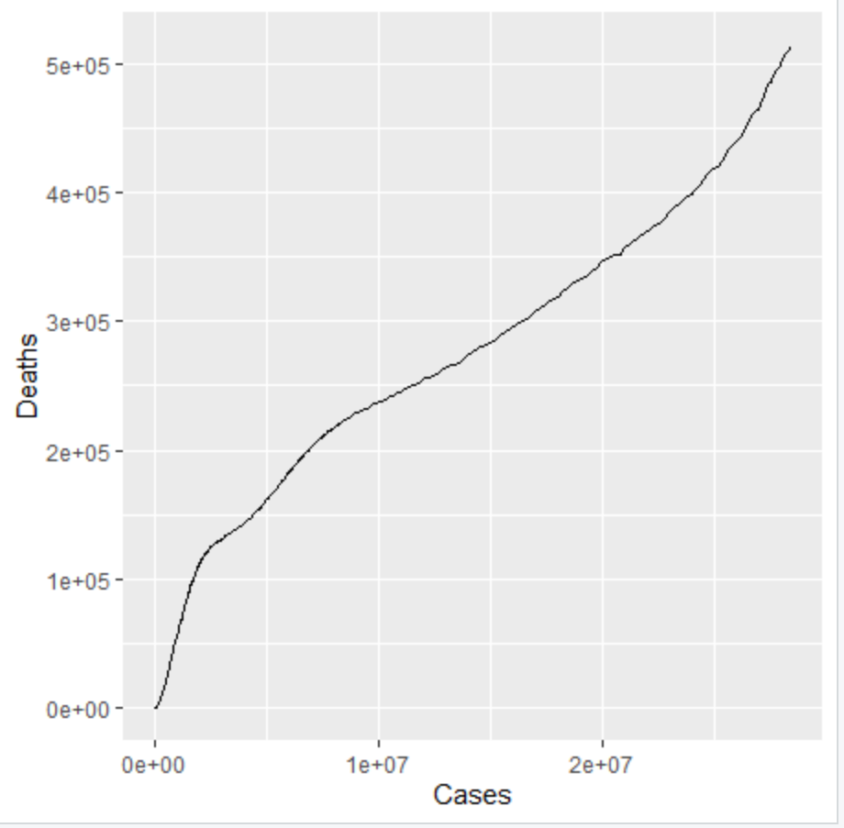

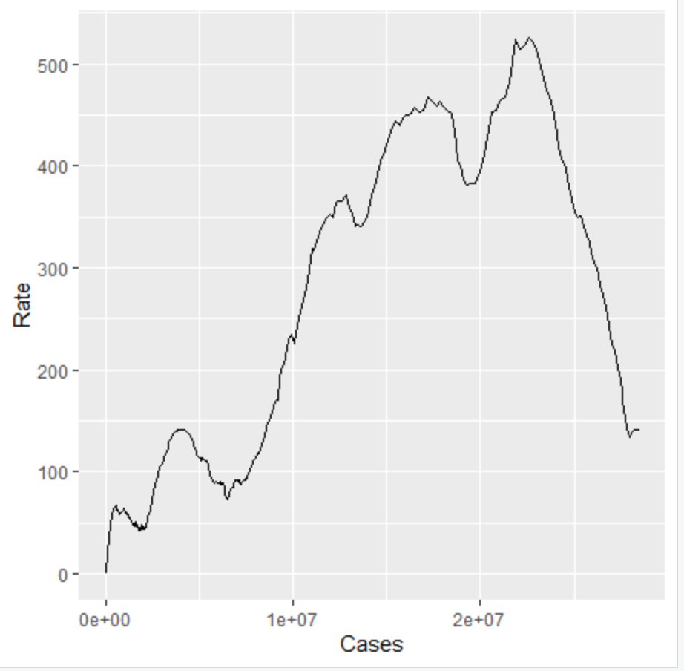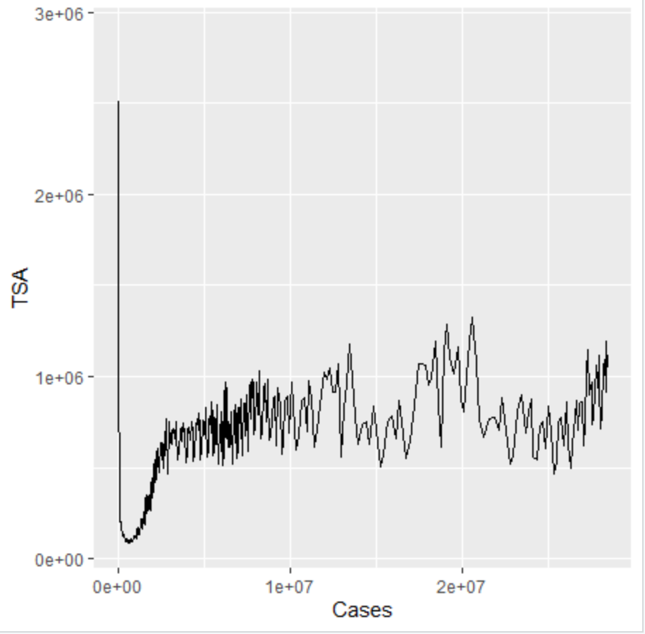

Based on the above initial data, it is clear to see that the amount of people passing through TSA at the airport significantly decreased as a result of COVID 19. The amount of people passing through TSA immediately began to pick up as travel restrictions began to become lifted, however numbers are still well below pre pandemic levels. In addition it is clear to see that there is a positive correlation between the total number of cases and the total number of deaths. However, as the Cases rose above approximately 2.5 million, the death rate per 100,000 cases started to decrease significantly, which could be indicative of several things: treatment of the symptoms improved as healthcare workers gained more knowledge and experience with cases, there were more resources mobilized to treat cases, the virus had potentially mutated to a less deadly strain, the susceptible/exposed population is more resilient (i.e. older/at risk population that was going to be exposed is already dead and only younger/less risky population is still being exposed).

**Nasdaq, Gold and Oil comparison with Covid 19 Data**

**Covid-19 Deaths, NDX, Gold and Oil Prices over Time**

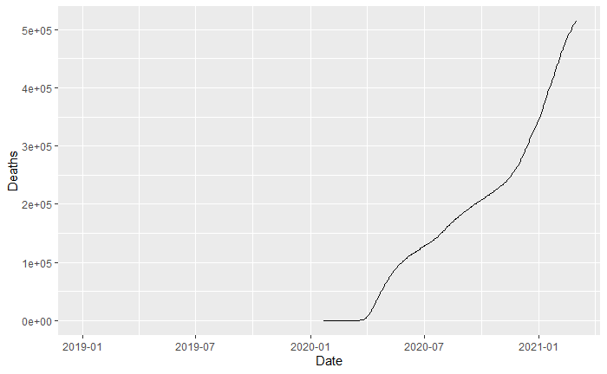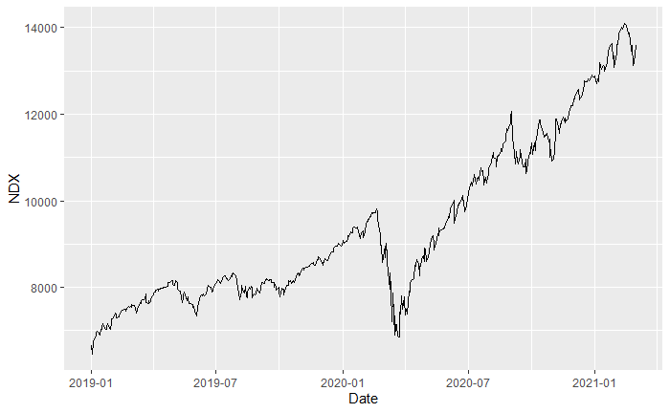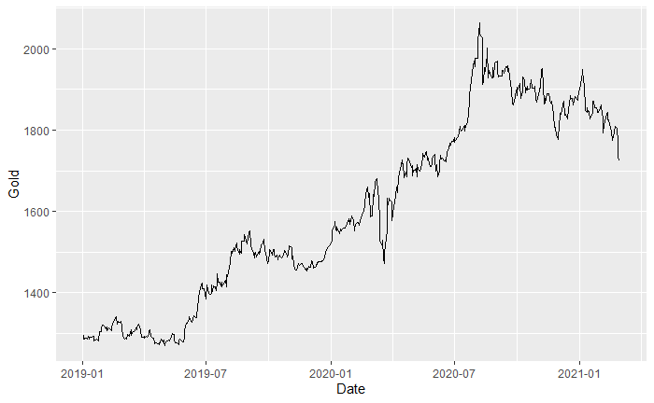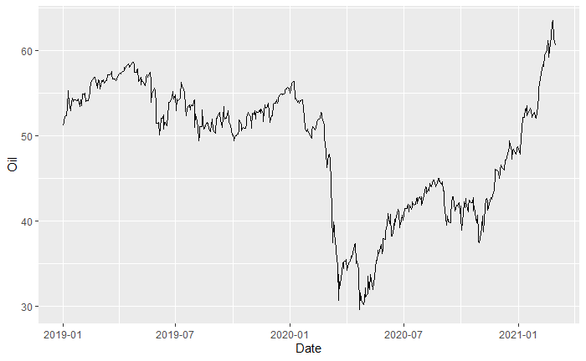

There is a clear dip in the Nasdaq (NDX) and Oil prices at the start of the Covid-19 pandemic. There is also a small, brief dip in Gold price as well, but it rapidly recovers. At this point, the NDX and Oil prices have recovered as well. All three prices seem to have maintained their original trend. This could lead to the hypothesis that all three prices are not positively correlated to Covid-19 deaths, at least not directly.

**NDX, Gold and Oil Prices vs. Covid-19 Cases**

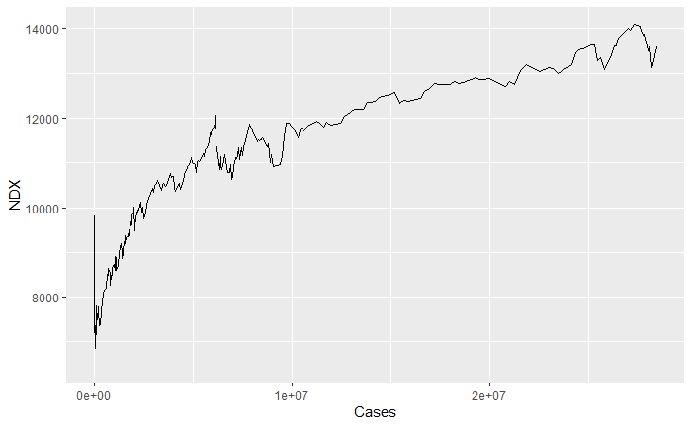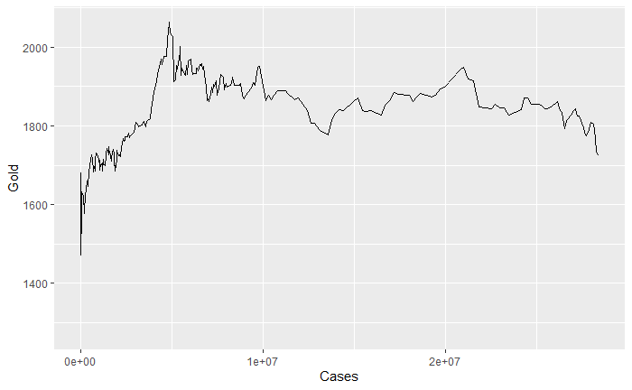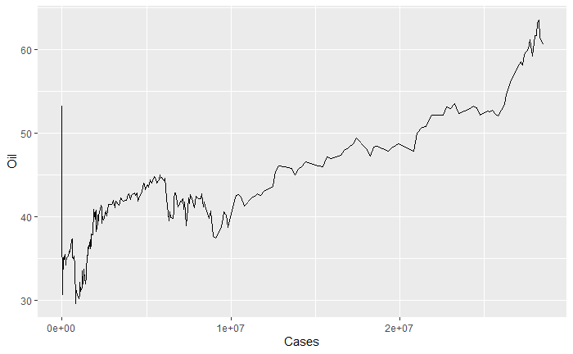

**NDX, Gold and Oil Prices vs. Covid-19 Deaths**

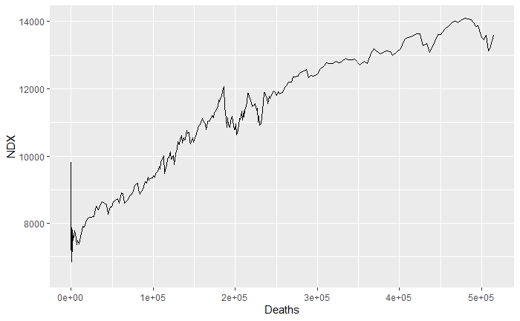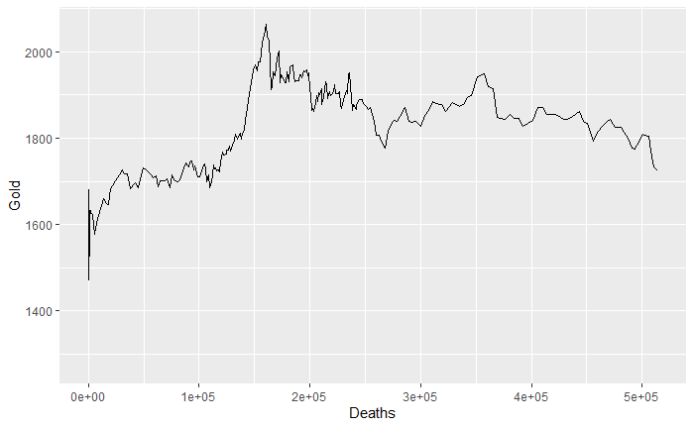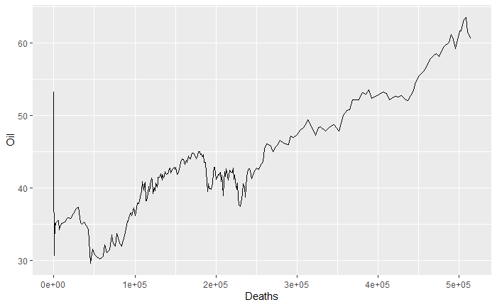

It can be seen from plots of prices vs. Cases or Death do not show any real correlation. One could make the assumption that the prices of NDX and Oil are positively correlated with both Cases and Deaths but that is more like just due to price increase over time, due to other factors.

There may be another factor at play, e.g. the initial news of the pandemic caused a scare that settled over time. Perhaps other factors such as macroeconomic indicators or the world’s rapid improvement in virtualization provided stability to the market.

**SPX, DOW, Bitcoin, GDP and Unemployment**

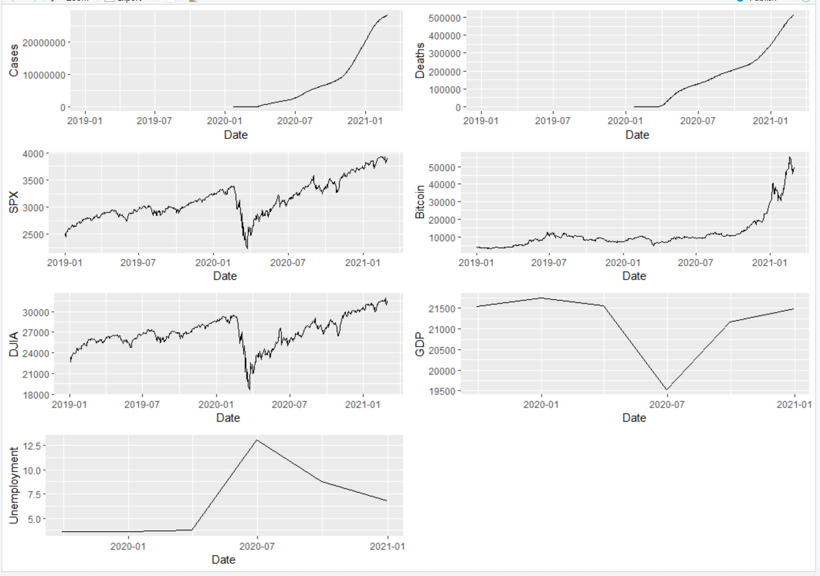

From the plots above we can see that the SPX, Bitcoin, DJIA, GDP and Unemployment dropped significantly and then later rebounding in early 2021.

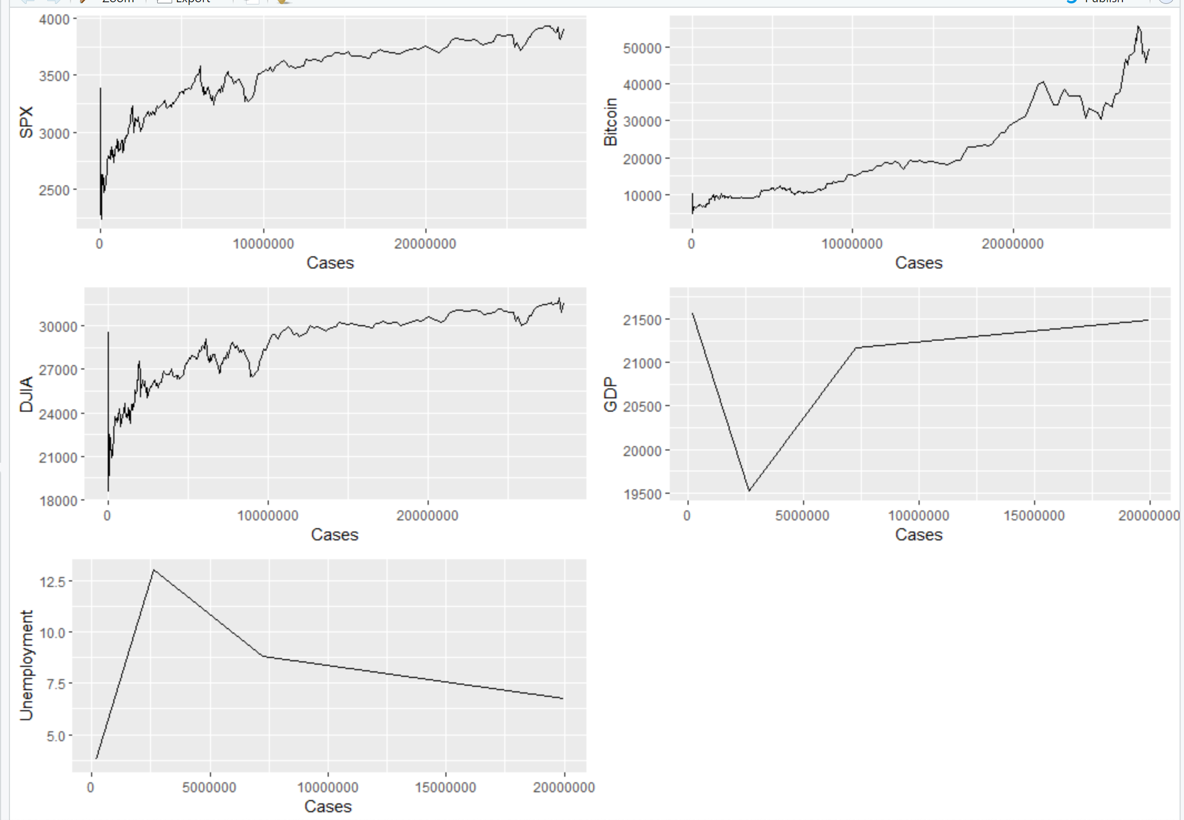

From the plots above we could see that the BTCUSD pair did not see significant fluctuation in its price during the pandemic, rest of the other markets responded to the case and their price were unstable until the cases hit 10M.

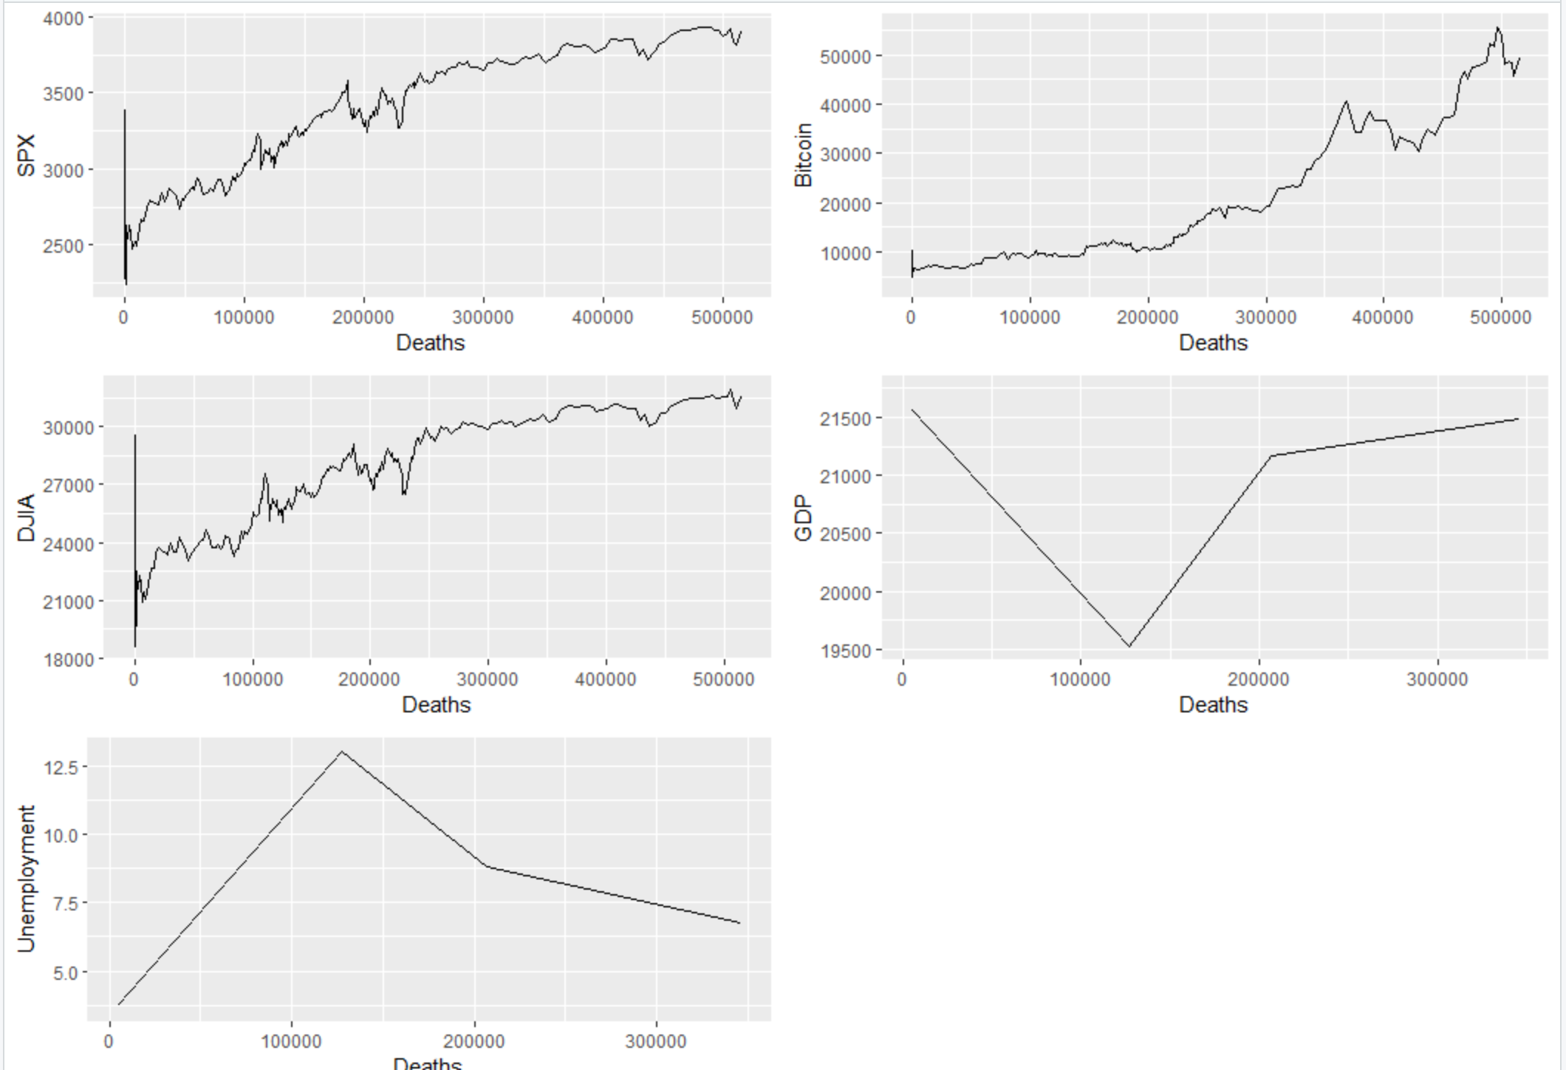

From the plots above we could see that the BTCUSD pair did not see significant fluctuation in its price during the pandemic, rest of the other markets responded to the case and their price were unstable until the death reached 100,000.

**Methods:**

Classification

1. Random forest
2. Regression
3. Wavelet transform

**References:**

[1]The relationship between cryptocurrencies and COVID-19 pandemic<https://www.ncbi.nlm.nih.gov/pmc/articles/PMC7388435/>

[2] Impact of COVID-19 on forecasting stock prices: An Integration of Stationary Wavelet Transform and Bidirectional Long Short-Term Memory <https://www.hindawi.com/journals/complexity/2020/1846926/>

[3] Bloomberg Terminal

|  |  |
| --- | --- |
| **Data** | **Function** |
| TSA Throughput | TSATTPCY |
| CoVID-19 Cases | NCOVUSCA |
| CoVID-19 Recovered | NCOVUSRE |
| CoVID-19 Deaths | NCOVUSDE |
| CoVID-19 Vaccine administered | NCOVUSVA |
| S&P 500 | SPX Index |
| Dow Jones | INDU Index |
| Nasdaq Composite | CCMP Index |
| Gold | XAU Curncy |
| Crude oil futures | C01 Comdty |
| Bitcoin/USD | XBTUSD |
| GDP, Non-farm payroll | ECST |